Nama : Frederico Steven Kwok
NPM : 242310037
Kelas : TI-24-PA1
Mata Kuliah : Lab. Pemrograman Perangkat Bergerak
Tugas : Pertemuan 6 – Tugas dan Latihan
Github : https://github.com/RicoSteven120206/PPB-Praktikum-242310037.git
Latihan 1: Membuat Struktur Drawer Navigasi
Buatlah kontainer _layout.jsx untuk mengatur halaman agar mekanisme menu dalam bentuk side-menu.
- Berikut Source Code untuk membuat container _layout pada Drawer Navigasi
Source Code main-apps/_layout.jsx
import { Ionicons } from "@expo/vector-icons";
import { Drawer } from "expo-router/drawer";
import { GestureHandlerRootView } from "react-native-gesture-handler";
import CustomDrawerContent from "../../components/praktikum-6/CostumDrawerContent";
import { color_list } from "../../components/styles/StyleApps";

export default function DrawerLayout() {
return (
<GestureHandlerRootView style={{ flex: 1 }}>
<Drawer
drawerContent={(props) => <CustomDrawerContent {...props} />}
screenOptions={{
headerShown: true,
headerStyle: { backgroundColor: color_list.green },
headerTintColor: "#fff",
headerTitleStyle: { fontWeight: "700" },
drawerActiveTintColor: color_list.green,
drawerInactiveTintColor: "gray",
drawerActiveBackgroundColor: color_list.green_light,
drawerLabelStyle: { fontSize: 14, fontWeight: "600" },
}}
>
<Drawer.Screen
name="(tabs)"
options={{
drawerLabel: "Katalog Buku",
title: "E-Catalog Buku",
drawerIcon: ({ color, size }) => (
<Ionicons name="home-outline" size={size} color={color} />
),
}}
/>
<Drawer.Screen
name="premium"
options={{
drawerLabel: "Premium Membership",
title: "Premium Membership",
drawerIcon: ({ color, size }) => (
<Ionicons name="star-outline" size={size} color={color} />
),
}}
/>
<Drawer.Screen
name="map-search"
options={{
drawerLabel: "Pencarian Peta",
title: "Pencarian Berbasis Peta",
drawerIcon: ({ color, size }) => (
<Ionicons name="map-outline" size={size} color={color} />
),
}}
/>
</Drawer>
</GestureHandlerRootView>
);
}

Source Code praktikum-6/CostumDrawerContent.jsx
import { Ionicons } from "@expo/vector-icons";
import {
DrawerContentScrollView,
DrawerItemList,
} from "@react-navigation/drawer";
import { Text, View } from "react-native";
import { color_list } from "../../components/styles/StyleApps";

export default function CustomDrawerContent(props) {
return (
<DrawerContentScrollView {...props}>
<View
style={{
padding: 20,
backgroundColor: color_list.green,
marginBottom: 10,
}}
>
<View
style={{
width: 60,
height: 60,
borderRadius: 30,
backgroundColor: "#fff",
justifyContent: "center",
alignItems: "center",
marginBottom: 10,
}}
>
<Ionicons name="book" size={30} color={color_list.green} />
</View>
<Text style={{ color: "#fff", fontSize: 18, fontWeight: "bold" }}>
E-Catalog Buku
</Text>
<Text style={{ color: "#e2e8f0", fontSize: 12 }}>
Baca. Jelajahi. Temukan.
</Text>
</View>
<DrawerItemList {...props} />
</DrawerContentScrollView>
);
}

Latihan 2: Tentukan Halaman Apa Saja Yang Akan Dibungkus Oleh Drawer
Buatlah minimal 3 buah menu pada kontainer Drawer. Masing-masing menu menampilkan infomasi terkait mengenai e-catalog buku.
- Pada isi container Drawer membuat beberapa Fitur Sidebar untuk menampilkan informasi terkait E-Catalog Book, berikut Source Code pada Pembuatannya
Source Code dari main-apps/_layout.jsx
<Drawer
drawerContent={(props) => <CustomDrawerContent {...props} />}
screenOptions={{
headerShown: true,
headerStyle: { backgroundColor: color_list.green },
headerTintColor: "#fff",
headerTitleStyle: { fontWeight: "700" },
drawerActiveTintColor: color_list.green,
drawerInactiveTintColor: "gray",
drawerActiveBackgroundColor: color_list.green_light,
drawerLabelStyle: { fontSize: 14, fontWeight: "600" },
}}
>
<Drawer.Screen
name="(tabs)"
options={{
drawerLabel: "Katalog Buku",
title: "E-Catalog Buku",
drawerIcon: ({ color, size }) => (
<Ionicons name="home-outline" size={size} color={color} />
),
}}
/>
<Drawer.Screen
name="premium"
options={{
drawerLabel: "Premium Membership",
title: "Premium Membership",
drawerIcon: ({ color, size }) => (
<Ionicons name="star-outline" size={size} color={color} />
),
}}
/>
<Drawer.Screen
name="map-search"
options={{
drawerLabel: "Pencarian Peta",
title: "Pencarian Berbasis Peta",
drawerIcon: ({ color, size }) => (
<Ionicons name="map-outline" size={size} color={color} />
),
}}
/>
</Drawer>

Berikut untuk isi Directory untuk Sidebar/Drawer Navigasi content.
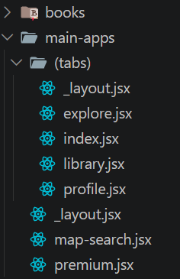
Berikut Source Code untuk Setiap Tampilan dari Drawer untuk menampilkan Informasi terkait dengan Buku.
Source Code dari main-apps/map-search.jsx
import { Ionicons } from "@expo/vector-icons";
import { Text } from "react-native";
import { SafeAreaView } from "react-native-safe-area-context";
import { color_list, styles } from "../../components/styles/StyleApps";

export default function MapSearchScreen() {
return (
<SafeAreaView style={[styles.container, { justifyContent: "center", alignItems: "center" }]}>
<Ionicons name="map" size={64} color={color_list.green} />
<Text style={{ fontSize: 20, fontWeight: "bold", marginTop: 15, textAlign: "center" }}>
Pencarian Berbasis Peta
</Text>
<Text style={{ color: "gray", textAlign: "center", marginTop: 8, paddingHorizontal: 30 }}>
Temukan perpustakaan atau toko buku terdekat berdasarkan lokasi Anda saat ini.
Fitur ini akan menampilkan peta interaktif dengan marker lokasi rekomendasi.
</Text>
</SafeAreaView>
);
}

Source Code dari main-apps/premium.jsx
import { AntDesign } from "@expo/vector-icons";
import { useRouter } from "expo-router";
import { FlatList, Image, Text, TouchableOpacity, View } from "react-native";
import { SafeAreaView } from "react-native-safe-area-context";
import { color_list, styles } from "../../components/styles/StyleApps";
import ListBook from "../../constants/list_book";

export default function PremiumScreen() {
const router = useRouter();
const premiumBooks = ListBook.filter((book) => !book.is_free);

return (
<SafeAreaView style={styles.container}>
<View style={{ padding: 15, backgroundColor: color_list.green, borderRadius: 12, marginTop: 10 }}>
<Text style={{ color: "#fff", fontSize: 20, fontWeight: "bold" }}>
Nikmati Semua Buku Premium
</Text>
<Text style={{ color: "#e2e8f0", marginTop: 5 }}>
Berlangganan untuk akses tak terbatas ke {premiumBooks.length} judul eksklusif.
</Text>
</View>

<FlatList
data={premiumBooks}
keyExtractor={(item) => item.id.toString()}
contentContainerStyle={{ paddingVertical: 15 }}
renderItem={({ item }) => (
<TouchableOpacity
style={{
flexDirection: "row",
backgroundColor: "#fff",
borderRadius: 10,
padding: 10,
marginBottom: 10,
}}
onPress={() => router.push(`/books/${item.id}`)}
>
<Image source={item.img} style={{ width: 60, height: 80, borderRadius: 6 }} />
<View style={{ marginLeft: 10, flex: 1, justifyContent: "center" }}>
<Text style={{ fontWeight: "bold" }}>{item.title}</Text>
<Text style={{ color: "gray", fontSize: 12 }}>{item.author}</Text>
<View style={{ flexDirection: "row", alignItems: "center", marginTop: 4 }}>
<AntDesign name="crown" size={14} color={color_list.orange} />
<Text style={{ marginLeft: 4, fontSize: 12 }}>Premium</Text>
</View>
</View>
</TouchableOpacity>
)}
/>
</SafeAreaView>
);
}

Latihan 3: Mengirimkan Parameter Antar Screen
Buatlah halaman detail buku pada semua item buku yang tersedia, dan tampilkan detail informasi buku tersebut seperti contoh digambar ini:

- Berikut Source Code untuk membuat tampilan Detail Buku berdasarkan params ID dari List Book untuk mengenai detail informasi buku.
Source Code dari app/books/[id].jsx
import { Ionicons } from "@expo/vector-icons";
import { useLocalSearchParams, useRouter } from "expo-router";
import {
Image,
ScrollView,
StatusBar,
StyleSheet,
Text,
TouchableOpacity,
View,
} from "react-native";
import { SafeAreaView } from "react-native-safe-area-context";

import ListBook from "../../constants/list_book";

export default function BookDetailScreen() {
const { id } = useLocalSearchParams();
const router = useRouter();

const book = ListBook.find((b) => b.id.toString() === id);

if (!book) {
return (
<SafeAreaView style={[styles.container, styles.centerAll]}>
<Text style={styles.errorText}>Buku tidak ditemukan</Text>
<TouchableOpacity
onPress={() => router.back()}
style={{ marginTop: 20 }}
>
<Text style={{ color: "white" }}>Kembali</Text>
</TouchableOpacity>
</SafeAreaView>
);
}

return (
<SafeAreaView style={styles.container}>
<StatusBar barStyle="light-content" backgroundColor="#1a2228" />

<View style={styles.header}>
<TouchableOpacity
onPress={() => router.back()}
style={styles.circleBtn}
>
<Ionicons name="arrow-back" size={24} color="#2D3748" />
</TouchableOpacity>
<View style={styles.headerRight}>
<TouchableOpacity style={styles.circleBtn}>
<Ionicons name="heart" size={24} color="#E2E8F0" />
</TouchableOpacity>
<TouchableOpacity style={styles.circleBtn}>
<Ionicons name="share-social" size={22} color="#2D3748" />
</TouchableOpacity>
</View>
</View>

<ScrollView
showsVerticalScrollIndicator={false}
contentContainerStyle={styles.scrollContent}
>
<Image source={book.img} style={styles.coverImage} />

<Text style={styles.title}>{book.title.toUpperCase()}</Text>
<Text style={styles.author}>{book.author}</Text>

<View style={styles.ratingRow}>
<Ionicons name="star" size={16} color="#EAB308" />
<Text style={styles.ratingText}>{book.rating} / 5.0</Text>
</View>

<View style={styles.synopsisBox}>
<Text style={styles.synopsisLabel}>SINOPSIS</Text>
<Text style={styles.synopsisText}>{book.sinopsis}</Text>

{book.story && (
<>
<Text style={[styles.synopsisLabel, { marginTop: 20 }]}>
STORY
</Text>
<Text style={styles.synopsisText}>{book.story}</Text>
</>
)}
</View>
</ScrollView>

<View style={styles.footer}>
{book.is_free ? (
<TouchableOpacity style={[styles.btnAction, styles.btnFree]}>
<Ionicons name="book-outline" size={20} color="#1E293B" />
<Text style={styles.txtFree}>Read Book</Text>
</TouchableOpacity>
) : (
<TouchableOpacity style={[styles.btnAction, styles.btnPremium]}>
<Ionicons name="card-outline" size={20} color="#FFF" />
<Text style={styles.txtPremium}>Subscribe</Text>
</TouchableOpacity>
)}
</View>
</SafeAreaView>
);
}

const styles = StyleSheet.create({
container: {
flex: 1,
backgroundColor: "#1a2228",
},
centerAll: {
justifyContent: "center",
alignItems: "center",
},
errorText: {
color: "#FFF",
fontSize: 18,
fontWeight: "bold",
},
header: {
flexDirection: "row",
justifyContent: "space-between",
paddingHorizontal: 20,
paddingTop: 10,
paddingBottom: 20,
},
headerRight: {
flexDirection: "row",
gap: 15,
},
circleBtn: {
width: 44,
height: 44,
borderRadius: 22,
backgroundColor: "#FFF",
justifyContent: "center",
alignItems: "center",
},
scrollContent: {
alignItems: "center",
paddingHorizontal: 20,
paddingBottom: 40,
},
coverImage: {
width: 200,
height: 200,
borderRadius: 16,
marginBottom: 25,
resizeMode: "cover",
},
title: {
color: "#FFF",
fontSize: 22,
fontWeight: "bold",
textAlign: "center",
marginBottom: 8,
},
author: {
color: "#E2E8F0",
fontSize: 16,
fontWeight: "500",
marginBottom: 10,
},
ratingRow: {
flexDirection: "row",
alignItems: "center",
marginBottom: 30,
},
ratingText: {
color: "#EAB308",
fontSize: 14,
fontWeight: "bold",
marginLeft: 6,
},
synopsisBox: {
width: "100%",
},
synopsisLabel: {
color: "#FFF",
fontSize: 18,
fontWeight: "bold",
marginBottom: 10,
},
synopsisText: {
color: "#CBD5E1",
fontSize: 15,
lineHeight: 24,
textAlign: "justify",
},
footer: {
padding: 20,
paddingBottom: 30,
backgroundColor: "transparent",
},
btnAction: {
flexDirection: "row",
width: "100%",
paddingVertical: 16,
borderRadius: 30,
justifyContent: "center",
alignItems: "center",
gap: 10,
},
btnPremium: {
backgroundColor: "#EAB308",
},
txtPremium: {
color: "#FFF",
fontSize: 18,
fontWeight: "bold",
},
btnFree: {
backgroundColor: "#FFF",
},
txtFree: {
color: "#1E293B",
fontSize: 18,
fontWeight: "bold",
},
});

Latihan 4: Laporan Singkat
- Buatlah dokumentasi dalam mengerjakan soal Latihan 1 hingga Latihan 3, dengan memberikan Screenshot baik dari sisi aplikasi ataupun code yang sudah dimodifikasi dengan penjelasan dan alur yang baik dan benar. Dokumentasi disimpan dalam bentuk PDF dan ditaruh dalam project react expo yang telah anda kerjakan.
- Dokumentasi pada Output Dari Pengerjaan
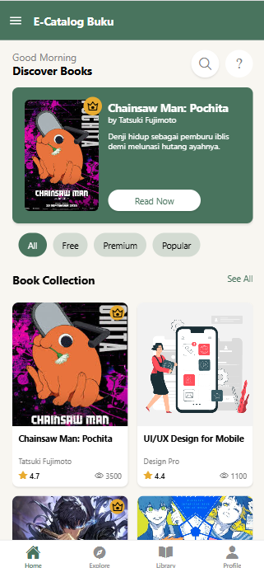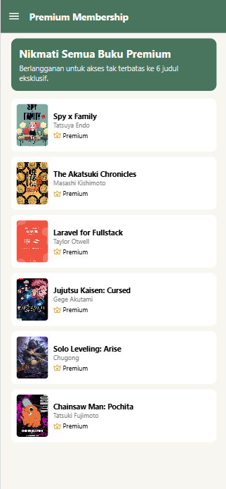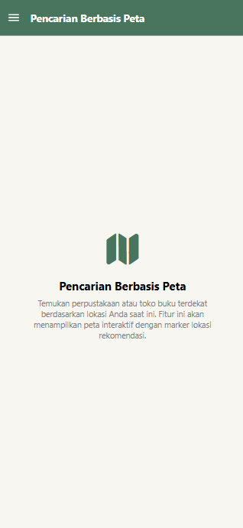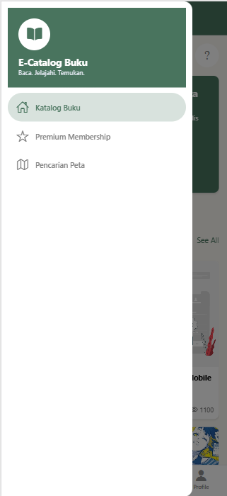
Berikut Output dari Detail Buku [id].jsx
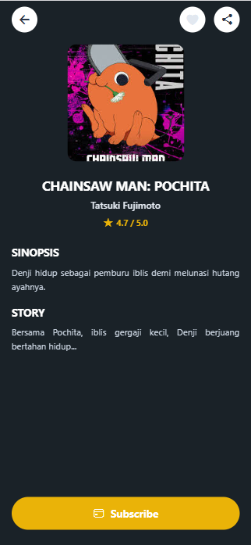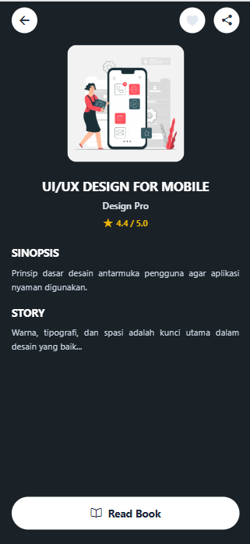
- Upload project tersebut pada GITHUB yang telah dibuat sebelumnya di repository "PPB-Praktikum-NPM", namun commit dengan nama "Tugas Praktikum-6".
- Pengumpulan Tugas Latihan Praktikum dikumpulkan selama 1 minggu kedepan sejak hari ini (sesuai dengan jadwal praktikum).
LINK REPOSITORY
https://github.com/RicoSteven120206/PPB-Praktikum-242310037.git

